Mickey Mouse Clubhouse
Group 11
Vincent Chen
Simon Zheng
Doraemon
Ryan Wang
Josh Chang

Table of Contents
Introduction 2
STP 2
Segmentation 2
Targeting 3
Positioning 3
Product 3
Pricing 4
Promotion 5
Brand Exposure 5
Consumer Research 5
Conclusion 6
Reference 6

Introduction
Taiwanese filter coffee, renowned for its distinct flavors and artisanal preparation, presents an exciting opportunity to introduce this premium product to the vibrant coffee culture of Los Angeles. By leveraging the city's reputation as a global trendsetter, we aim to showcase the unique qualities of Taiwanese filter coffee and capture the attention of discerning coffee connoisseurs. Taiwan has a long and rich history of coffee cultivation, dating back to the 17th century when the Dutch introduced the crop to the island. The country's diverse microclimates and high-altitude growing regions produce a wide variety of specialty coffee beans with unique flavors, from fruity and floral to earthy and complex. Taiwanese coffee farmers use sustainable and organic farming practices, ensuring the quality and environmental impact of their products. Taiwanese filter coffee is renowned for its delicate floral aromas, light body, and subtle sweetness. The unique terroir of Taiwan's high-altitude tea farms lends these beans a bright, clean flavor profile that is distinctly different from other East Asian coffee origins. Slow manual brewing methods like pour-over highlight the nuanced flavors and balanced acidity of Taiwanese coffee. The small-scale, artisanal production also ensures exceptional quality and consistency in each cup.

STP

Segmentation

Demographic:
In demographic segmentation, our consideration is the income of US divided by classes.
Lower class: <$30000
Lower-middle class: $30001-$58020
Middle class: $58021-$94000
Upper-middle class: $94001-$153000
Upper class:> $153000

Geographic:
Since population of US is massive, it has many megalopolises, and the top 3 are The Great Northeast, The Great Lakes and Northern California.

Psychographic:
We decided to take lifestyle in consideration, which is the frequency of drinking coffee. There are 72.9% drink every day, 16.1% drink few times a week, 3.8% once a week, 3.5% once every few weeks, 1.1% once a month and 2.6% less often than once a month.

Targeting
Our target consumers are the middle-class office and administrative support workers in the Northeast megalopolis who drink coffee every day.

Positioning:
Compared to other coffee brands, our San Coffee offers a competitive advantage with its moderate pricing and high quality. This aligns perfectly with the consumption habits of the middle class, allowing them to purchase quality products at a lower cost.
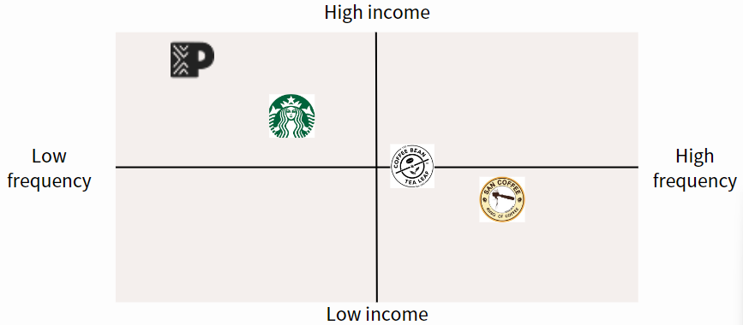

Product
We used coffee bags, coffee capsules and coffee beans to compare with our drip coffee. Obviously, the advantage about drip coffee and instant coffee are similar. There are quite convenient, requiring only open the package and add hot water to brew, but they also have some disadvantages, like drip coffee have less control over quality. About instant coffee is that hardened due to moisture. If you compare the two, Drip coffee provides an experience and taste closer to freshly brewed coffee. In addition to the above-mentioned advantages of drip coffee, our products - San coffee also have environmentally friendly packaging and customized roasting. The remaining two are coffee capsules and coffee beans. Coffee capsules are favored for their convenience, allowing users to brew coffee quickly with minimal effort and mess. They ensure consistency in flavor and strength as each capsule contains a precise amount of coffee. A wide variety of flavors cater to different tastes. However, they tend to be more expensive than loose coffee and raise environmental concerns due to materials like aluminum or plastic. Brands are working on recyclable or biodegradable options. Using capsules requires a compatible coffee machine, adding to initial costs. About the last one is coffee bean, the pros of coffee beans are that you can enjoy the original flavor of coffee and enjoy the process of grinding coffee beans. However, the cons of coffee beans are grinding coffee beans and brewing require a coffee machine, so you have to go back and clean the coffee machine after brewing, which is a relatively troublesome process.

Pricing
We use pricing strategy,it advantages of penetration pricing include like

Market Penetration:
Attract more consumers to enter the market, especially price-sensitive consumers, by setting lower prices. This helps quickly increase market share and build brand awareness in a highly competitive market.

Accelerate Product Promotion:
Low prices can encourage consumers to try new products or services, thus accelerating the market promotion and popularity of products. This is especially important for new brands or products.

Deter Competitors:
Entering the market at low prices may prevent competitors from adopting similar strategies or reduce their market share, thereby gaining a competitive advantage in a highly competitive market environment.

Take Advantage of Economies of Scale:
Through large-scale sales, you can achieve scale advantages in costs, so you may be able to obtain higher profit margins by increasing prices in the future.

Consumer Loyalty:
Through initial low prices and active marketing, consumer loyalty and reputation can be established, thereby laying the foundation for long-term development.
Above all, penetration pricing strategy can help companies quickly enter the market and establish brand influence. Although it may sacrifice some profit margins, in the long run, it is usually an effective market entry strategy.

Promotion

Brand Exposure
Coffee shops are ideal locations for introducing new products. These establishments are frequented by coffee enthusiasts who are open to exploring new coffee varieties and brands. By partnering with coffee shops, Deep Kousa Drip Coffee can directly reach its target consumers, effectively increasing brand exposure and creating product familiarity among regular visitors.

Consumer Research (to support brand exposure)
According to a study by the Specialty Coffee Association (SCA), 75% of consumers are willing to try new products recommended by coffee shops. This statistic underscores the high potential for new product adoption in coffee shop settings. Coffee shops play a crucial role in influencing consumer choices and preferences, making them a strategic venue for promoting new coffee products. By leveraging the trust and authority of coffee shop recommendations, San Drip Coffee can significantly boost its market acceptance and consumer trial rates.

Conclusion
Unique Opportunity: Introducing Taiwanese filter coffee to Los Angeles offers a chance to showcase its rich history, diverse flavors, and sustainable practices.

Target Market: Focus on middle-class office and administrative support workers in the Northeast megalopolis who drink coffee daily.

Product Positioning: San Coffee provides high-quality, moderately priced drip coffee, offering convenience and a taste closer to freshly brewed coffee with eco-friendly packaging.

Pricing Strategy: Use penetration pricing to attract price-sensitive consumers, increase market share, and build brand awareness quickly.

Promotion Strategy: Partner with coffee shops to leverage their influence and increase brand exposure, supported by research showing high consumer willingness to try new products recommended by coffee shops.

Reference
https://sca.coffee/research
https://sancoffee.shop/
https://www.peets.com/collections/all-menu-items
https://coffeebean.com/
https://www.starbucks.com.tw/home/index.jspx
https://www.bls.gov/emp/tables/emp-by-detailed-occupation.htm
https://www.driveresearch.com/market-research-company-blog/coffee-survey/
https://www.statista.com/statistics/1327743/coffee-consumption-frequency-in-the-us/

